ITSE ASSIGNMENT 2
Agile Software Engineering Practice Report
University Management System (UMS)
Group | 2
Team Size | 2 Students
Team Members | Saba Rani (25F-3055)  Ahmad Afan Khan(25M-3028)
Assigned Features | Student Management; Faculty Management; Examination Management
Number of Sprints | 2 (plus Sprint 3 for carry-over/rework)
Jira Project | University Management System (Key: UMS)  25m-3028-ahmad-afan-khan.atlassian.net/jira/software/projects/UMS

Question 1 — Introduction

1.1 Problem Statement
The university currently faces difficulties in managing student records, faculty information, and examination-related activities through separate or manual processes. This can lead to duplicate records, outdated information, communication gaps, and difficulty in accessing accurate academic information. Students may face delays when their information needs to be updated or verified, while faculty and administrative staff may spend additional time maintaining records and coordinating examination activities.
The proposed University Management System (UMS) will provide a centralized system for Student Management, Faculty Management, and Examination Management. It will help maintain accurate student and faculty records and support organized examination activities through a common system.
The main stakeholders affected by this problem are students, faculty members, examination staff, and university administrators. Students need accurate personal and academic information, faculty members need reliable faculty records and examination-related information, while administrative and examination staff need an organized way to manage records and examination activities.

1.2 Product Vision
To provide a centralized University Management System for students, faculty members, examination staff, and university administrators that simplifies Student Management, Faculty Management, and Examination Management by reducing manual work, duplicate records, and communication gaps. The system will allow authorized users to maintain accurate student and faculty information and manage examination activities in an organized manner. The expected outcome is improved data accuracy, easier access to information, better coordination among university stakeholders, and reduced administrative effort.

1.3 Logical Scope & Relationships Between Features
The three assigned features — Student Management, Faculty Management, and Examination Management — form a logical scope for one software increment because none of them is functionally independent; each depends on data or actions produced by the others.
First, Student Management and Examination Management are related through enrollment: an examination cannot be created or scheduled for a student unless that student already exists as a verified, enrolled record in Student Management. Examination Management therefore reads and depends on student data rather than duplicating it.
Second, Faculty Management and Examination Management are related through invigilation: every examination requires a faculty member to be assigned as an invigilator. Faculty Management stores faculty availability and workload information, and Examination Management uses this data to assign a faculty member without double-booking them at an overlapping time.
Because these three modules share entities (Student, Faculty) and a common lifecycle — enroll, teach or supervise, then examine — they can realistically be built and demonstrated together as one meaningful increment rather than as three unrelated mini-systems.

1.4 Assumptions
Assumption 1: Each course offering has exactly one scheduled examination per semester.
Justification: The project scope is limited to three features with a two-sprint timeline. Modeling multiple exam types (midterm, final, resit) per course would significantly increase the size of the data model and the number of user stories required, which is not realistic to deliver within two short sprints.
Assumption 2: Only one faculty member is assigned as the primary invigilator per examination.
Justification: In practice, larger examination halls may require multiple invigilators. However, supporting a many-to-many relationship between faculty and examinations would add considerable complexity to both the data model and the user interface for a feature that is not the central focus of this increment. A single-invigilator assignment keeps the related user story small enough to estimate and test within one sprint.
Question 2 — Agile Software Development
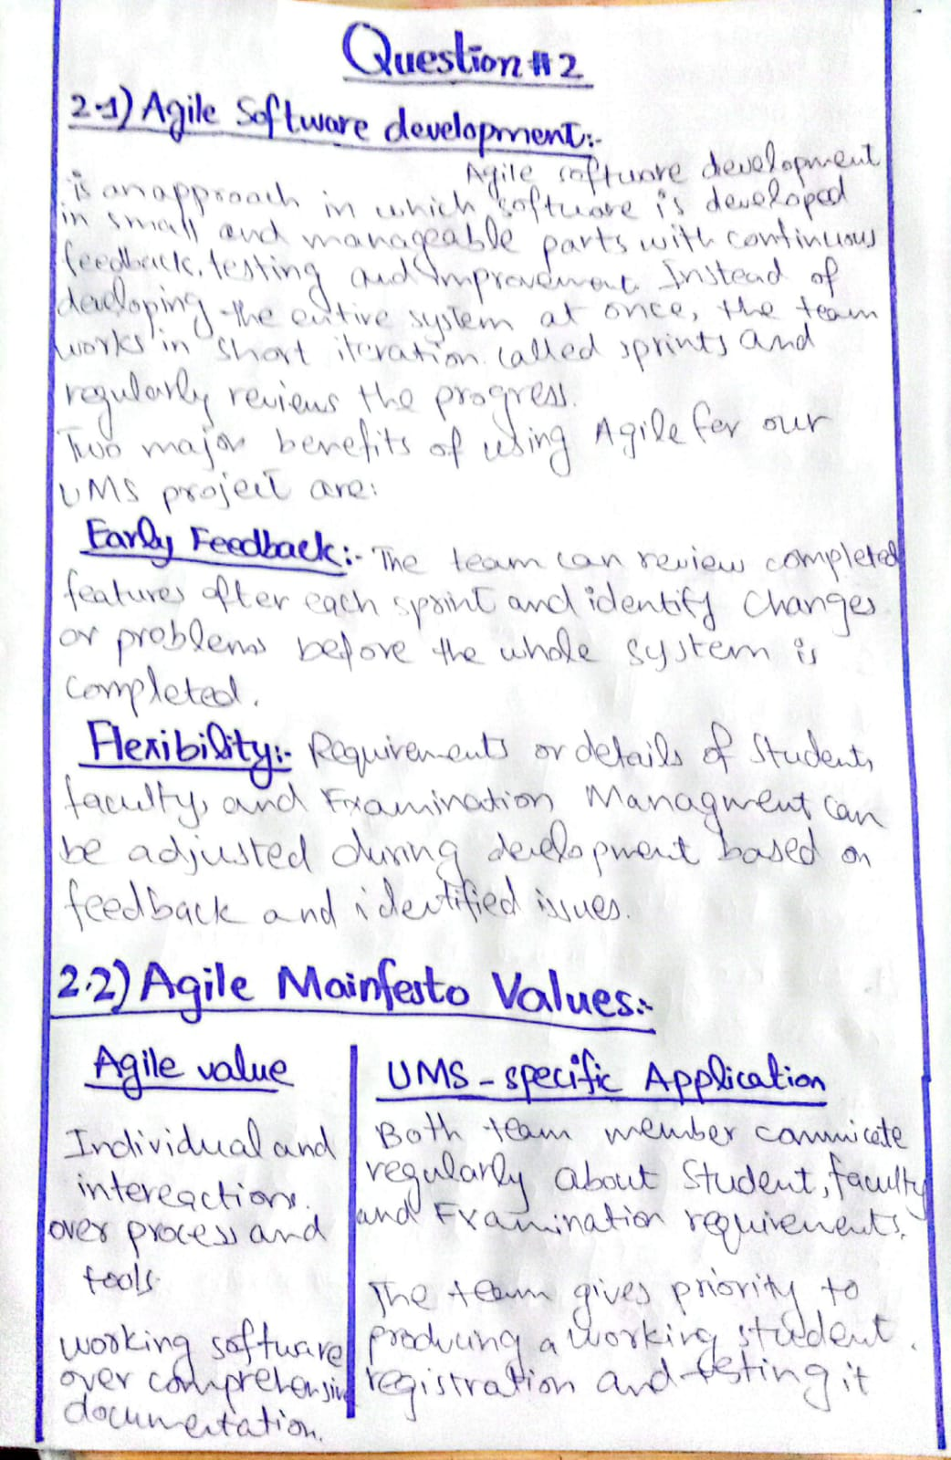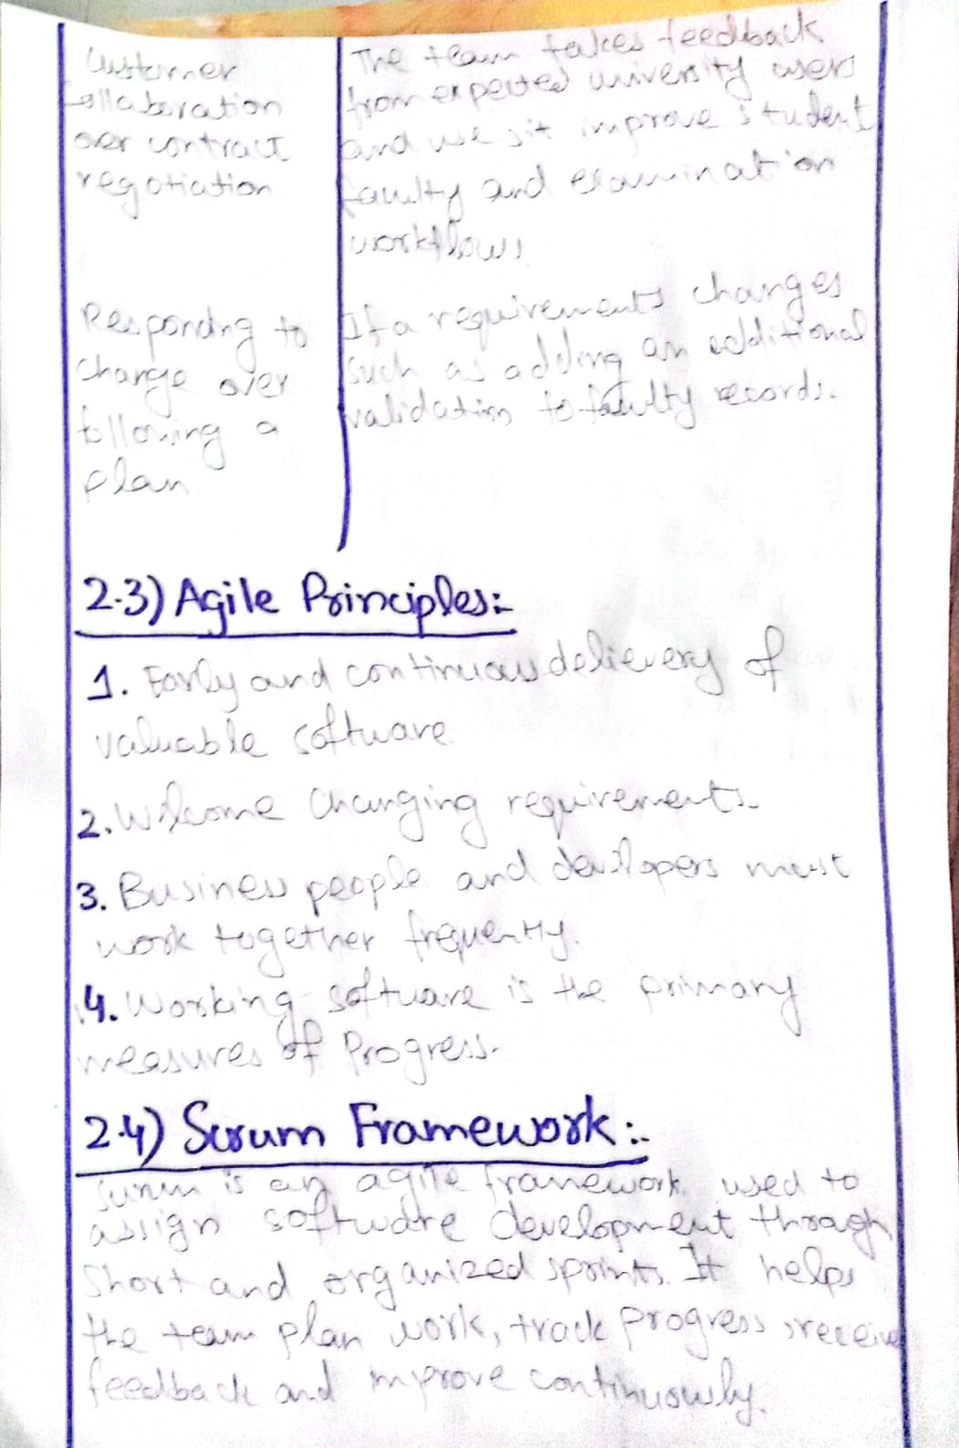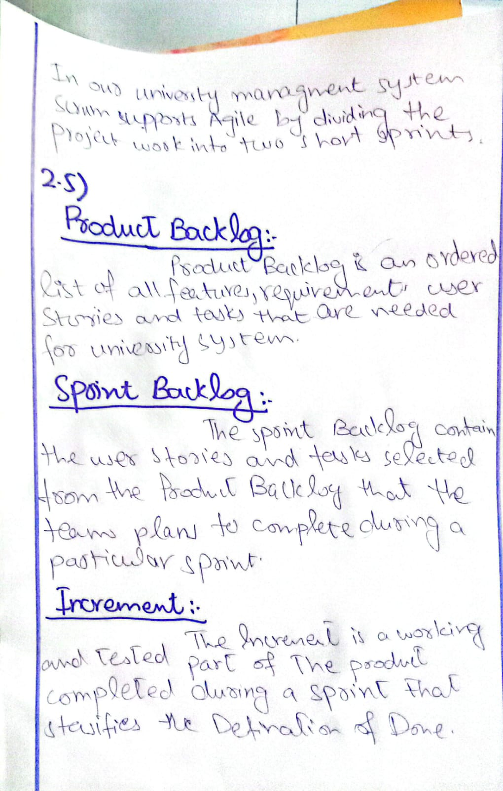
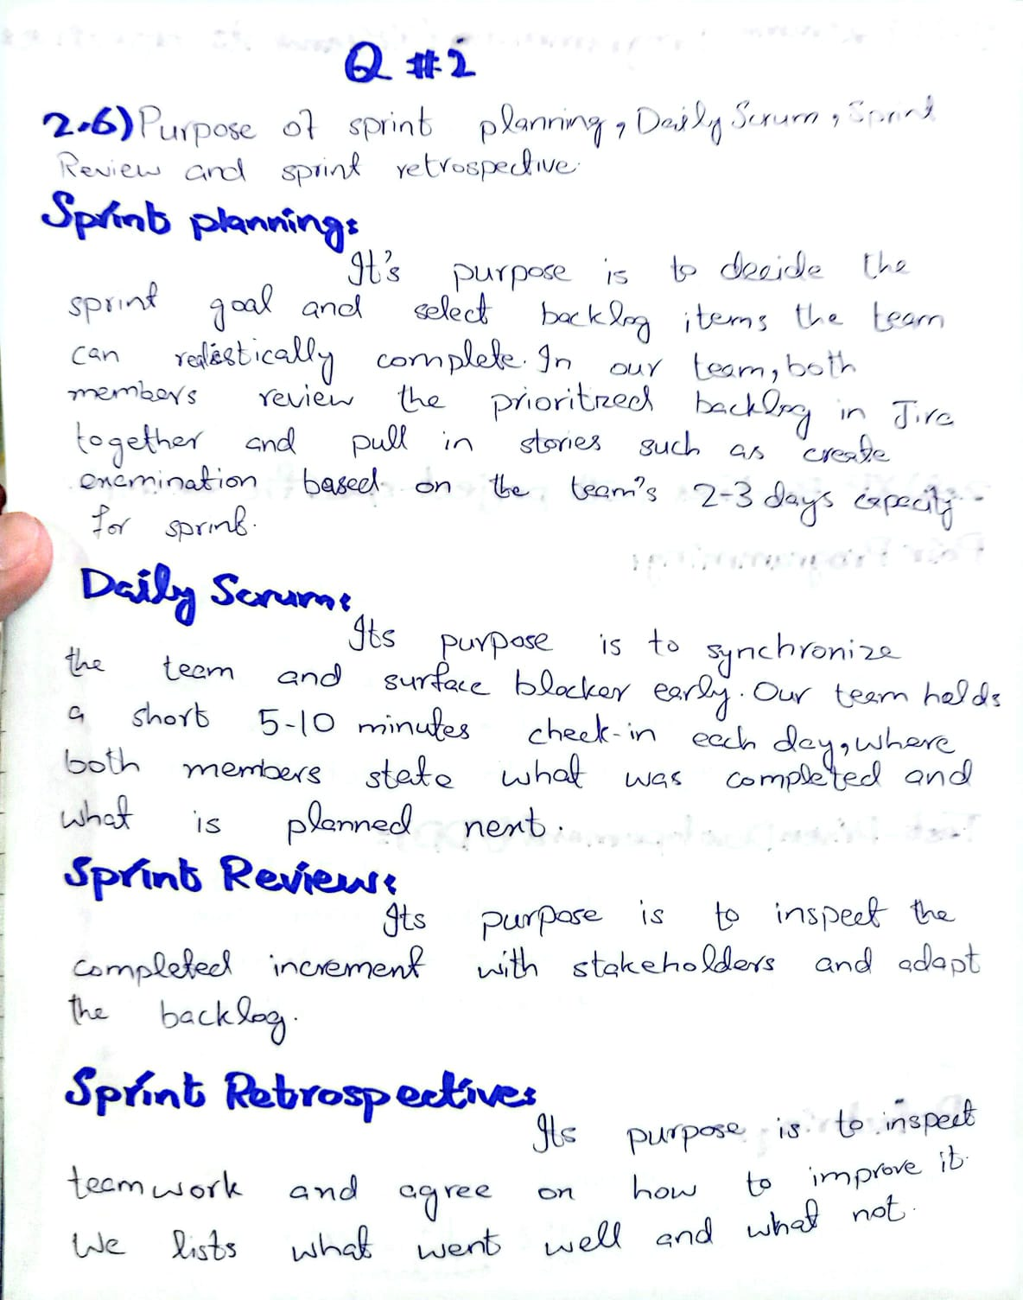

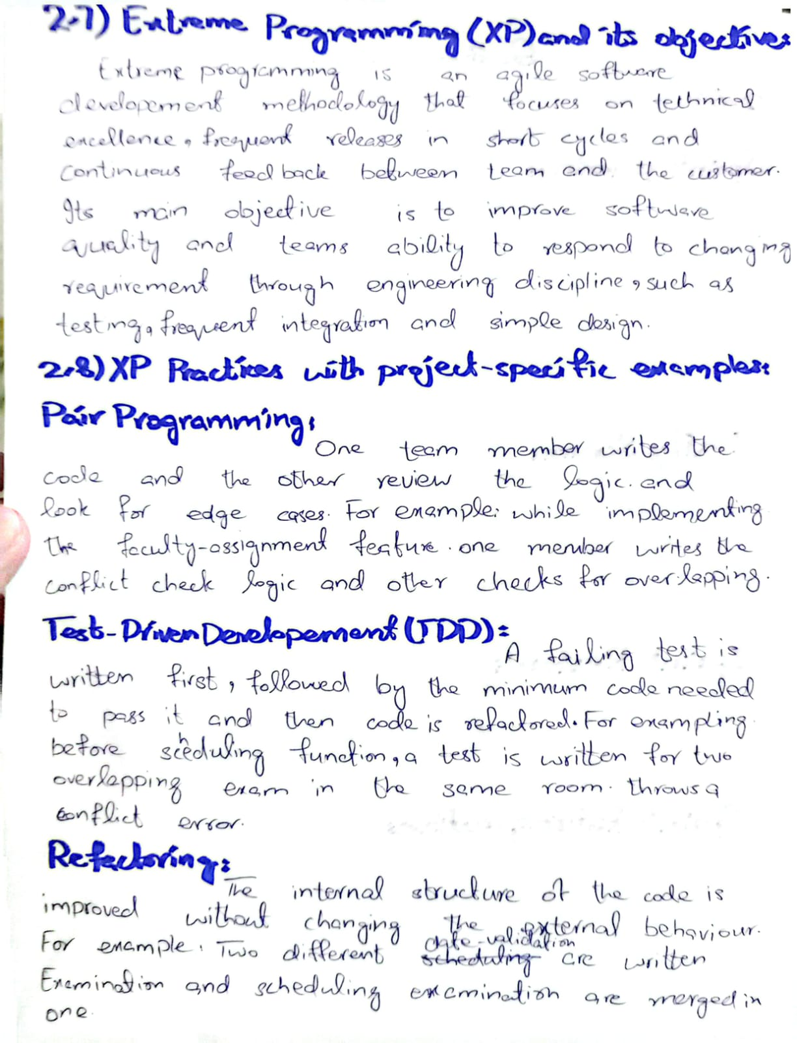

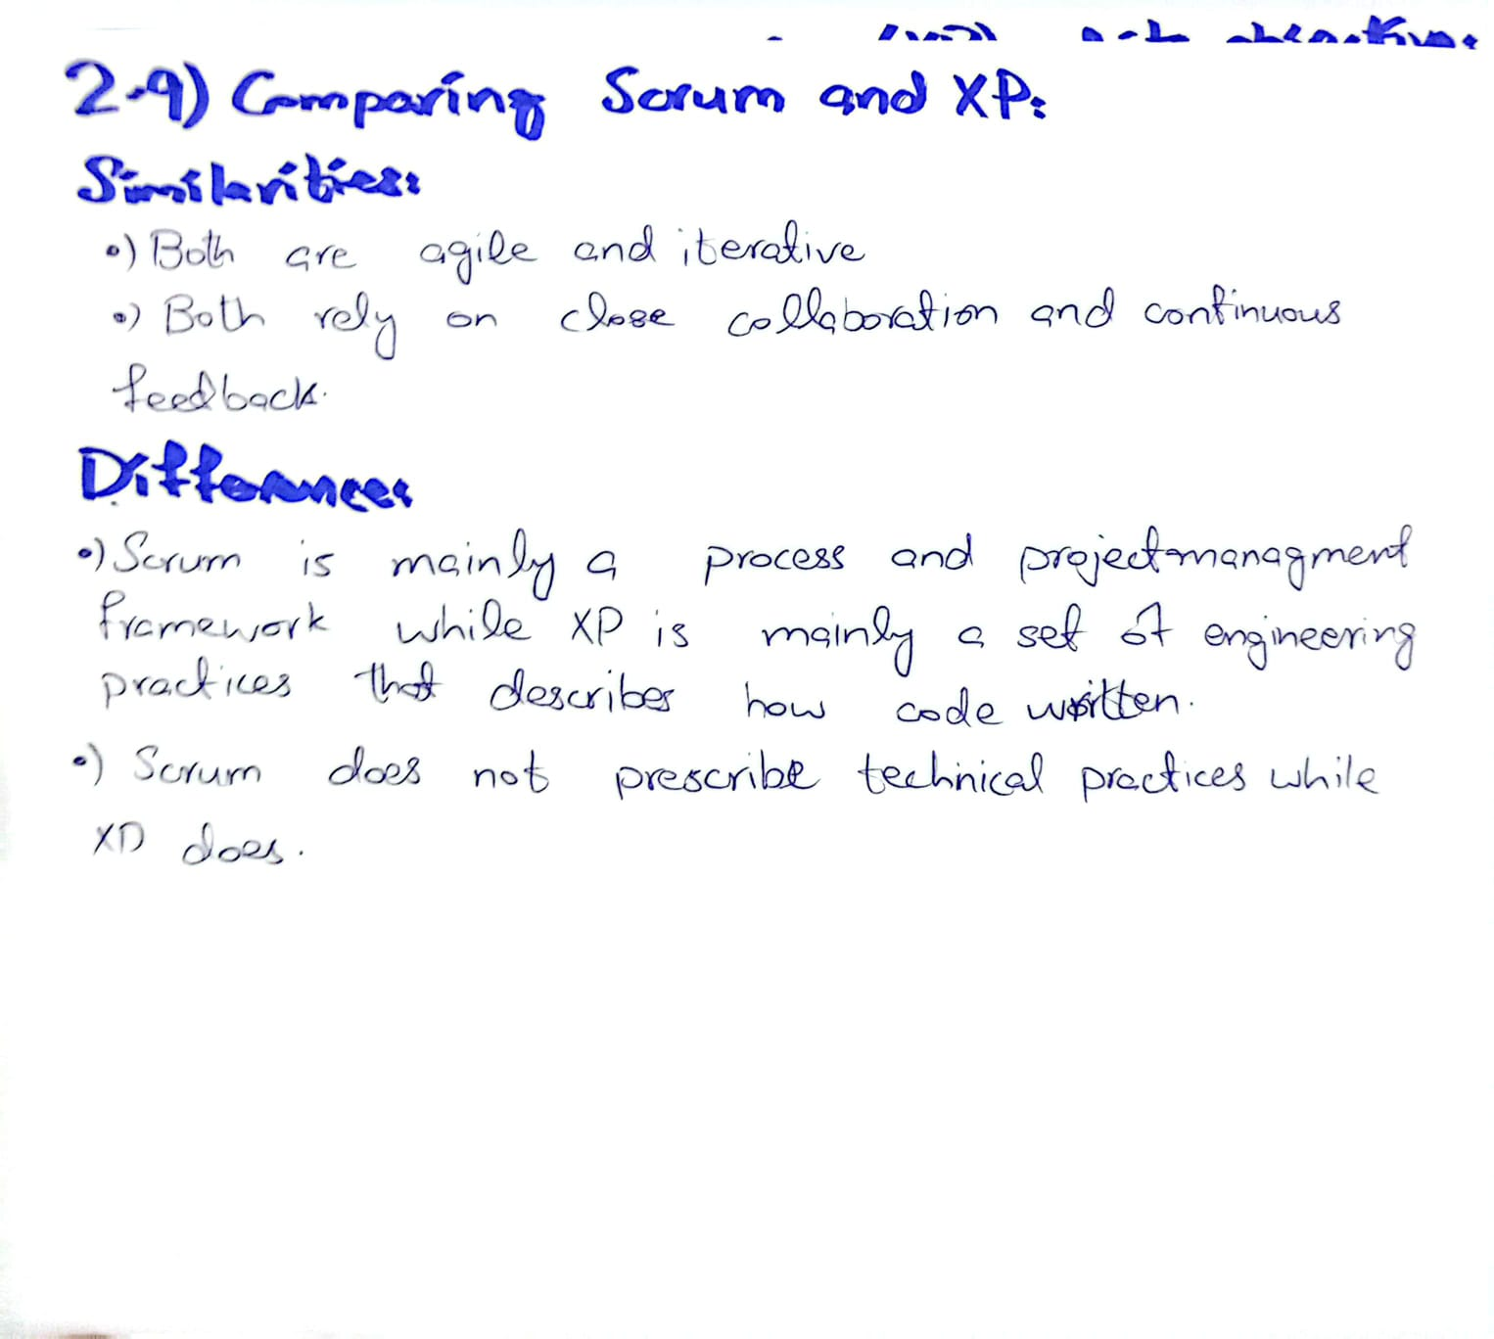

Question 3 — Backlog Artifacts & Definition of Done

3.1 Product Backlog (Screenshot)

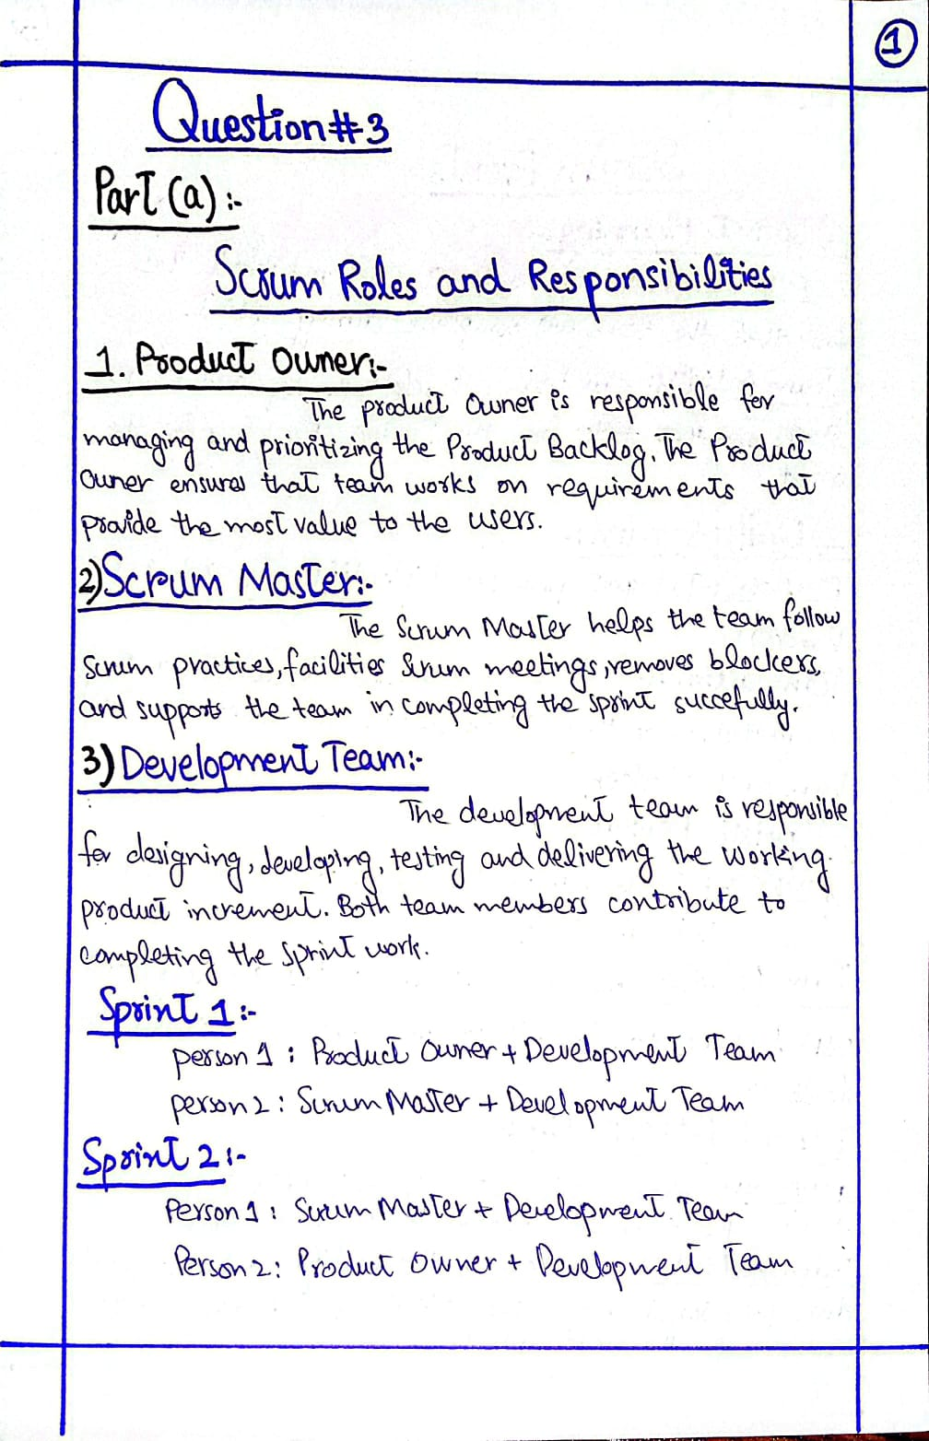

3.2 Sprint Backlog (Screenshot)

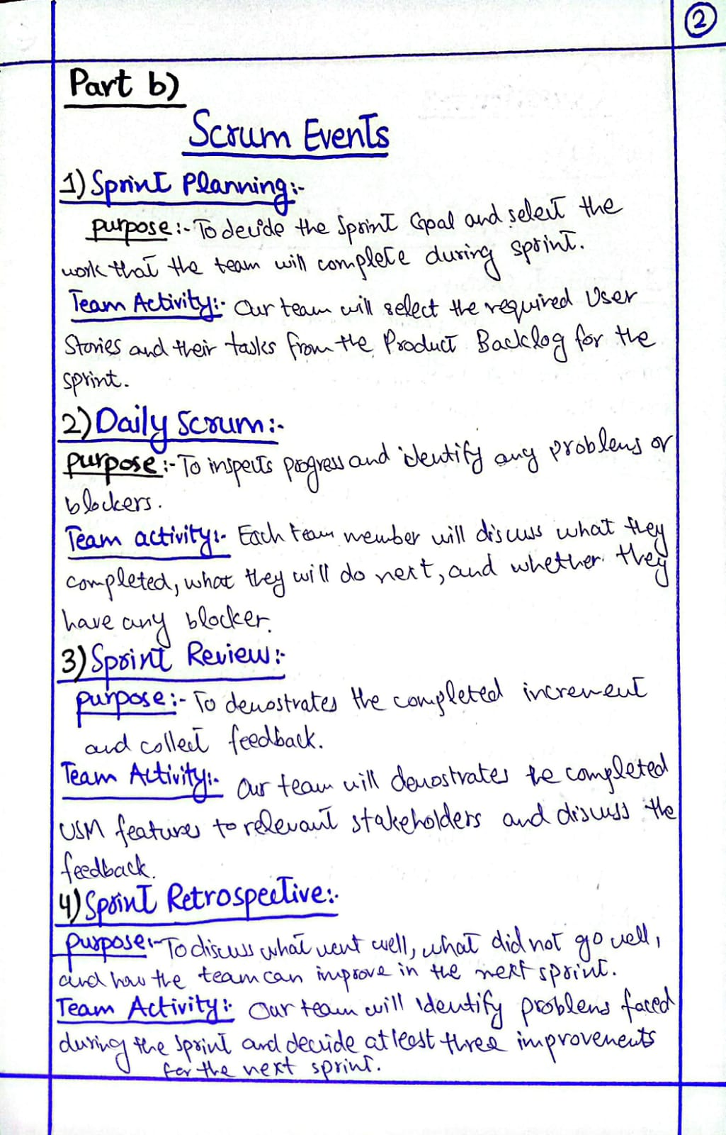

3.3 Product Backlog, Sprint Backlog and Increment — Applied to UMS

Product Backlog
The Product Backlog is the complete ordered list of requirements, User Stories, features, and tasks needed for the University Management System.
Example: US-01 Register Student, US-02 Update Student, US-05 Register Faculty, and US-09 Create Examination are examples of items in the Product Backlog.

Sprint Backlog
The Sprint Backlog contains the User Stories and tasks selected from the Product Backlog that the team plans to complete in a specific Sprint.
Example: For Sprint 1, the team may select US-01 Register Student, US-02 Update Student, and US-03 Search Student with their related tasks.

Increment
The Increment is the working and tested part of the University Management System completed during a Sprint that satisfies the Definition of Done.
Example: After Sprint 1, the completed and tested Student Registration and Student Search features can be part of the Increment.

3.4 Definition of Done
A User Story will be considered Done in our University Management System when all of the following conditions are satisfied:
- The required functionality has been completely implemented according to the User Story.
- All defined Acceptance Criteria have been satisfied.
- The code has been reviewed by the team member.
- The implemented functionality has been tested successfully.
- No critical or blocking defects remain.
- The feature works correctly with the existing UMS components.
- The code has been committed to the Git repository.
- The completed work is updated to the Done status in Jira.

Question 4 — Requirements Engineering, User Stories & Acceptance Criteria
Before configuring Jira, the assigned UMS scope was converted into Agile requirements: functional requirements, non-functional requirements, user stories, acceptance criteria, and an INVEST evaluation. These directly drove the backlog and sprint planning used in Questions 6 and 7.

4(a) Functional Requirements
At least 12 functional requirements were identified, distributed evenly across the three assigned features (4 per feature).
ID | Functional Requirement | Feature
FR-01 | The system shall allow authorized users to register a new student with their personal and academic details. | Student Management
FR-02 | The system shall allow authorized users to update an existing student's information. | Student Management
FR-03 | The system shall allow authorized users to search for a student by roll number or name. | Student Management
FR-04 | The system shall allow a logged-in student to view their own academic profile. | Student Management
FR-05 | The system shall allow authorized users to register a new faculty member with their personal and department details. | Faculty Management
FR-06 | The system shall allow authorized users to update an existing faculty member's information. | Faculty Management
FR-07 | The system shall allow authorized users to search for a faculty member by name or department. | Faculty Management
FR-08 | The system shall allow an Exam Coordinator to view a faculty member's current availability and workload. | Faculty Management
FR-09 | The system shall allow an Exam Coordinator to create a new examination record for a course. | Examination Management
FR-10 | The system shall allow an Exam Coordinator to schedule the date, time, and room for an examination. | Examination Management
FR-11 | The system shall allow an Exam Coordinator to assign a faculty member as invigilator to a scheduled examination, while preventing double-booking. | Examination Management
FR-12 | The system shall allow students and faculty to view the examination schedule relevant to them. | Examination Management

4(b) Non-Functional Requirements
At least 5 non-functional requirements relevant to the UMS scope were identified, covering performance, security, usability, reliability, and availability/access control.
ID | Requirement | Justification
NFR-01  Performance | Common operations such as registering a student, updating student information, searching for a student, and viewing a student profile should be completed within 3 seconds under normal system load. | Fast response time improves the user experience and allows university staff to manage student records efficiently without unnecessary delays.
NFR-02  Security | Only authorized users should be allowed to access or modify student, faculty, and examination records, controlled through proper authentication and authorization. | The system handles important university information, so protecting records from unauthorized access is necessary to maintain privacy and data security.
NFR-03  Usability | The system should have a simple, clear, and user-friendly interface for registering, updating, searching, and viewing records without unnecessary steps. | A simple interface reduces user confusion and allows university staff to learn and use the system efficiently.
NFR-04  Reliability | Examination records and schedule changes must be saved immediately once submitted; no scheduling data should be lost due to a system crash or network interruption. | Losing examination data during the exam period could directly affect students and faculty, so reliable saving of records is necessary to maintain trust in the system.
NFR-05  Usability | An Exam Coordinator with no prior training should be able to create and schedule an examination in under 3 minutes, using a simple and clearly labeled form. | Exam Coordinators manage many examinations across a semester, so an efficient and easy-to-use process reduces administrative effort and the chance of user error.
NFR-06  Security / Access Control | Only users with the Exam Coordinator or Admin role should be able to create, schedule, or reassign examinations. Students and faculty have read-only access to their relevant schedule. | Examination information is sensitive and directly affects academic outcomes, so restricting who can create or modify it is necessary to prevent unauthorized changes.

4(c) & 4(d) User Stories with Acceptance Criteria
At least 12 user stories were written across the three assigned features, each following the As a [user], I want [functionality], so that [benefit] format. Every story is supported by at least 4 testable acceptance criteria.

Student Management

US-01 — Register Student
As a university administrator, I want to register a new student in the system, so that the student's academic record can be maintained digitally.
- The system requires mandatory fields (name, roll number, program, contact details) to be filled before saving.
- The system rejects registration if the roll number already exists in the database.
- A confirmation message is displayed once the student record is successfully saved.
- The newly registered student appears immediately in student search results.

US-02 — Update Student
As a university administrator, I want to update a student's information, so that the student's record remains accurate and up to date.
- Only authorized users can access the student update form.
- Changes are validated against the same rules as registration (e.g., valid contact format) before saving.
- The system displays a confirmation message once the update is saved successfully.
- The updated information is immediately reflected when the student profile is viewed again.

US-03 — Search Student
As a university administrator, I want to search for a student using the student's roll number or name, so that I can quickly find the correct student record.
- The user can search using either the student's roll number or name.
- Searching an existing roll number or name returns the exact matching student record.
- Searching a non-existent roll number or name returns a clear “no results found” message.
- Search results display at minimum the student's name, roll number, and program.

US-04 — View Student Profile
As a student, I want to view my own academic profile, so that I can verify my personal and academic information is correct.
- A logged-in student can only view their own profile, not another student's.
- The profile displays the student's personal details, program, and current status.
- The profile page loads within the performance target defined in NFR-01.
- An error message is shown if the profile data cannot be retrieved.

Faculty Management

US-05 — Register Faculty
As a university administrator, I want to register a new faculty member in the system, so that their details are available for scheduling and academic records.
- The system requires mandatory fields (name, department, designation, contact details) before saving.
- The system rejects registration if the same faculty ID or email already exists.
- A confirmation message is displayed once the faculty record is successfully saved.
- The newly registered faculty member appears immediately in faculty search results.

US-06 — Update Faculty
As a university administrator, I want to update a faculty member's information, so that department and contact details remain accurate.
- Only authorized users can access the faculty update form.
- Changes are validated for correct format (e.g., valid email, phone number) before saving.
- The system displays a confirmation message once the update is saved.
- The updated details are reflected immediately when the faculty profile is viewed again.

US-07 — Search Faculty
As a university administrator, I want to search for a faculty member by name or department, so that I can quickly find the correct faculty record.
- The user can search using either the faculty member's name or department.
- Searching an existing name or department returns the matching faculty record(s).
- Searching a non-existent name or department returns a “no results found” message.
- Search results display at minimum the faculty member's name, department, and designation.

US-08 — View Faculty Availability
As an Exam Coordinator, I want to view a faculty member's current availability and workload, so that I can assign invigilation duties without conflicts.
- The Exam Coordinator can view a faculty member's assigned examinations and time slots.
- The system flags a faculty member as “unavailable” for any time slot where they are already assigned.
- Availability data updates immediately after a new invigilation assignment is made.
- An error message is shown if the faculty member's availability data cannot be retrieved.

Examination Management

UMS-12 — Create Examination
As an Exam Coordinator, I want to create a new examination record for a course, so that the exam can later be scheduled and staffed.
- The Exam Coordinator can create an examination record only for an existing, valid course.
- Mandatory fields (course, exam type, semester) must be completed before the record is saved.
- The system prevents creating a duplicate examination for the same course and exam type in one semester.
- A confirmation message is displayed once the examination record is created.

UMS-13 — Schedule Examination
As an Exam Coordinator, I want to set the date, time, and room for an existing examination, so that students and faculty know when and where it will occur.
- The Exam Coordinator can set a date, time, and room only for an existing examination record.
- The system rejects a schedule if the date falls outside the semester's date range.
- The system prevents scheduling two examinations in the same room with overlapping times.
- A confirmation message is displayed once the schedule is saved successfully.

UMS-14 — Assign Faculty to Examination
As an Exam Coordinator, I want to assign a faculty member as invigilator to a scheduled examination, so that exam supervision is properly staffed.
- The Exam Coordinator can assign a faculty member only to a scheduled examination.
- The system prevents assigning a faculty member who is already invigilating an overlapping examination.
- A confirmation message is displayed once the faculty member is successfully assigned.
- The assigned faculty member's availability is updated immediately after assignment.

UMS-15 — View Examination Schedule
As a student or faculty member, I want to view the examination schedule relevant to me, so that I know when and where my exams or invigilation duties occur.
- A student can view only the examinations relevant to their own enrolled courses.
- A faculty member can view only the examinations they are assigned to invigilate.
- The schedule displays the date, time, room, and course for each examination.
- An appropriate message is shown if no examinations are currently scheduled.

4(e) INVEST Evaluation
At least 6 user stories were evaluated using INVEST (Independent, Negotiable, Valuable, Estimable, Small, Testable). Weaknesses were identified for two stories, each followed by an improved version.

US-01 — Register Student
INVEST Principle | Evaluation
I — Independent | The story can be developed independently without requiring the completion of another student-management story.
N — Negotiable | The exact registration fields and interface details can be discussed and adjusted by the team.
V — Valuable | It provides value by allowing university staff to create student records efficiently.
E — Estimable | The team can estimate the effort because the required functionality and acceptance criteria are clear.
S — Small | The story focuses only on registering a student and is small enough to be completed within a Sprint.
T — Testable | The story can be tested by checking whether valid student information is successfully saved and invalid information is rejected.
INVEST Result: US-01 satisfies all six INVEST principles and is suitable for implementation.

US-02 — Update Student
INVEST Principle | Evaluation
I — Independent | The story can be developed separately from other student-management stories.
N — Negotiable | The specific editable fields and update interface can be discussed and changed according to requirements.
V — Valuable | It provides value by keeping student information accurate and updated.
E — Estimable | The required update functionality is clear enough for the team to estimate its relative effort.
S — Small | The story focuses only on updating existing student information and can be completed within a Sprint.
T — Testable | The story can be tested by verifying that valid changes are saved correctly and invalid information is handled properly.
INVEST Result: US-02 satisfies the INVEST principles and is suitable for implementation.

US-03 — Search Student (original wording evaluated below)
Original User Story: As a university administrator, I want to search for a student by relevant information, so that I can quickly find the required student record.
INVEST Principle | Evaluation
I — Independent | The story can be developed separately from other student-management stories.
N — Negotiable | The search fields and search interface can be discussed and adjusted according to the team's requirements.
V — Valuable | It provides value by helping university staff find student records quickly and efficiently.
E — Estimable | The search functionality is clear enough for the team to estimate its relative effort.
S — Small | The story focuses on searching student records and can be completed within a Sprint.
T — Testable | Weak: the phrase “relevant information” does not clearly specify which fields can be used to search, making the story harder to test precisely.
Identified Weakness: The Testable aspect is weak because “relevant information” does not clearly specify which information can be used to search for a student.
Improved User Story: As a university administrator, I want to search for a student using the student's roll number or name, so that I can quickly find the correct student record. (This improved wording is the version used as US-03 throughout the rest of this report.)
Why It Is Better: The improved User Story clearly identifies the search criteria, making the requirement more specific, easier to estimate, implement, and test.

UMS-12 — Create Examination
INVEST Result: Independent, Negotiable, Valuable, Estimable, and Small. Its Testable aspect is slightly weak, since “create” alone does not specify validation rules — this is addressed by the acceptance criteria defined in Section 4(d).

UMS-13 — Schedule Examination
INVEST Result: Negotiable, Valuable, Estimable, and Testable. Its Independent aspect is weak, since it can only be completed after UMS-12 (Create Examination) already exists.

UMS-14 — Assign Faculty to Examination (original scope evaluated below)
Original User Story: As an Exam Coordinator, I want to assign a faculty member as invigilator to a scheduled examination, so that exam supervision is properly staffed, and no faculty member is double-booked.
INVEST Result: Independent (once UMS-13 is done), Negotiable, Valuable, and Testable. Its Small aspect is weak.
Identified Weakness: The story bundles two separate behaviors into one: assigning a faculty member to an exam, and preventing that faculty member from being double-booked on an overlapping exam. This makes the story larger and harder to estimate and test as a single unit than it should be.
Improved User Story: Split into two stories — UMS-14: “As an Exam Coordinator, I want to assign a faculty member as invigilator to a scheduled examination, so that exam supervision is properly staffed,” and a new story: “As an Exam Coordinator, I want to be prevented from assigning a faculty member who is already invigilating an overlapping examination, so that no faculty member is double-booked.”
Why It Is Better: Splitting the double-booking rule into its own story makes each story smaller and independently testable. The basic assignment can be implemented and demonstrated first, and the conflict-prevention rule can be estimated, built, and tested separately, without one piece of functionality blocking the other.
Question 5 —Product Backlog, Prioritization & Estimation
(a) Product Backlog Epics
The University Management System (UMS) Product Backlog is organized into exactly three Epics, corresponding to the three assigned features.
Epic 1: Student Management
This Epic contains the user stories related to registering, updating, searching, and viewing student information.
- UMS-4 — Register Student
- UMS-5 — Update Student
- UMS-6 — Search Student
- UMS-7 — View Student Profile
Epic 2: Faculty Management
This Epic contains the user stories related to registering, updating, searching, and viewing faculty information.
- UMS-8 — Register Faculty
- UMS-9 — Update Faculty
- UMS-10 — Search Faculty
- UMS-11 — View Faculty Profile
Epic 3: Examination Management
This Epic contains the user stories related to creating, scheduling, assigning faculty, and viewing examination schedules.
- UMS-12 — Create Examination
- UMS-13 — Schedule Examination
- UMS-14 — Assign Faculty to Examination
- UMS-15 — View Examination Schedule
Thus, the backlog contains exactly 3 Epics and 12 user stories, with 4 stories under each Epic.
(b) Product Backlog with Tasks/Subtasks
Story | User Story | Assignee | Tasks/Subtasks
UMS-4 | Register Student | Person 1 | Create registration form; Add input validation
UMS-5 | Update Student | Person 1 | Create update function; Validate updated information
UMS-6 | Search Student | Person 1 | Implement search function; Test search results
UMS-7 | View Student Profile | Person 1 | Create profile view; Display student information
UMS-8 | Register Faculty | Person 1 | Create faculty form; Validate faculty data
UMS-9 | Update Faculty | Person 1 | Create update function; Test updated records
UMS-10 | Search Faculty | Person 1 | Implement faculty search; Test search functionality
UMS-11 | View Faculty Profile | Person 1 | Create faculty profile view; Verify displayed information
UMS-12 | Create Examination | Person 2 | Create examination form; Validate examination data
UMS-13 | Schedule Examination | Person 2 | Implement date/time selection; Add conflict checking; Test schedule
UMS-14 | Assign Faculty to Examination | Person 2 | Implement faculty assignment; Check faculty availability
UMS-15 | View Examination Schedule | Person 2 | Create schedule display; Test schedule information
The backlog contains 24 tasks/subtasks in this breakdown, which exceeds the minimum requirement of 18 tasks/subtasks.

(c) Prioritization Strategy
The user stories were prioritized using business value, user value, risk, urgency, and dependencies.
Story | Priority | Reason
UMS-4 Register Student | High | Student records are a basic requirement for the system
UMS-5 Update Student | High | Accurate student information is required for other operations
UMS-6 Search Student | Medium | Important for accessing records quickly
UMS-7 View Student Profile | Medium | Provides useful student information to authorized users
UMS-8 Register Faculty | High | Faculty records are required before faculty can be assigned to examinations
UMS-9 Update Faculty | High | Accurate faculty data is needed for reliable assignments
UMS-10 Search Faculty | Medium | Supports quick access to faculty records
UMS-11 View Faculty Profile | Medium | Provides detailed faculty information
UMS-12 Create Examination | High | Examination records are required before scheduling
UMS-13 Schedule Examination | High | Scheduling is a core examination-management function and has higher risk
UMS-14 Assign Faculty to Examination | High | Depends on faculty and examination records and is important for examination execution
UMS-15 View Examination Schedule | Medium | Provides users with access to finalized examination schedules
The highest-priority stories are those that provide core functionality, have important dependencies, or carry greater operational risk.
(d) Story Point Estimation
The Fibonacci-style scale 1, 2, 3, 5, and 8 was used for estimation.
Story | Story Points
UMS-4 Register Student | 5
UMS-5 Update Student | 3
UMS-6 Search Student | 3
UMS-7 View Student Profile | 3
UMS-8 Register Faculty | 5
UMS-9 Update Faculty | 3
UMS-10 Search Faculty | 3
UMS-11 View Faculty Profile | 3
UMS-12 Create Examination | 5
UMS-13 Schedule Examination | 8
UMS-14 Assign Faculty to Examination | 5
UMS-15 View Examination Schedule | 3
Story points represent relative complexity, effort, uncertainty, and dependencies, rather than hours. A story with more uncertainty or more interacting parts receives a higher relative estimate.
(e) Justification of Three Estimates
1. UMS-13 — Schedule Examination: 8 Story Points
This story is estimated at 8 because it involves several interacting requirements, including selecting date and time, assigning a venue, checking conflicts, and saving the finalized schedule. It also has greater uncertainty and dependency on examination data. Therefore, it is more complex than a 5-point story but does not require splitting into multiple independent features for this assignment.
2. UMS-12 — Create Examination: 5 Story Points
Create Examination is estimated at 5 because it requires a form, validation, and saving examination information. It is more complex than a simple search or profile-view story, which is why it is 5 rather than 3. However, it has less complexity and uncertainty than Schedule Examination, so it does not require 8 points.
3. UMS-14 — Assign Faculty to Examination: 5 Story Points
This story is estimated at 5 because it requires selecting a faculty member, linking the faculty member with an examination, and checking faculty availability. The dependency between faculty and examination records adds some complexity. It is therefore larger than a simple 3-point story but less complex than the 8-point scheduling story.

Question 6 — Jira Project Configuration

6(a) Jira Project Setup
A Jira Scrum project named University Management System (project key: UMS) was created and actively used throughout the assignment, at 25m-3028-ahmad-afan-khan.atlassian.net/jira/software/projects/UMS. Both team members were added with edit access, and Story Points estimation was enabled on the board.

6(b) Epics, User Stories and Tasks/Subtasks
The UMS project contains exactly 3 Epics, one for each assigned feature: UMS-1 Student Management, UMS-2 Faculty Management, and UMS-3 Examination Management. Under these epics, 12 user stories were created (4 per epic), and 30 tasks/subtasks were created and linked to their parent stories, exceeding the required minimum of 18.
Examination Management (Person 2's epic, UMS-3):
ID | User Story | Story Points | Priority
UMS-12 | Create Examination | 5 | High
UMS-13 | Schedule Examination | 8 | High
UMS-14 | Assign Faculty to Examination | 5 | High
UMS-15 | View Examination Schedule | 3 | High

6(c) Issue Fields
Every story under Examination Management includes a summary, a full description written in the As a/I want/so that format, an epic link to UMS-3, a priority, story points, an assignee, acceptance criteria written in the description, and a current status. For example, UMS-13 (Schedule Examination) has: Summary “Schedule Examination”; Priority High; Story Points 8; Assignee Person 2; Status Done; and four acceptance criteria covering date/time selection, venue assignment, conflict prevention, and saving the finalized schedule.

6(d) Workflow
The board uses the workflow To Do → In Progress → Code Review → Testing → Done, as recommended by the assignment. Issues are moved through these statuses as work genuinely progresses, with a short comment added at each transition (for example, noting when a pull request is opened or when CI passes).

6(e) Sprints Executed
Two sprints were created and executed in Jira: UMS Sprint 1 and UMS Sprint 2 (a third sprint, UMS Sprint 3, also exists on the board for carry-over/rework items). Sprint 1 focused on the core Student and Faculty Management stories. Sprint 2 focused on the remaining Faculty Management stories together with the entire Examination Management epic (UMS-12 through UMS-15), all of which are marked Done.

6(f) Jira Evidence
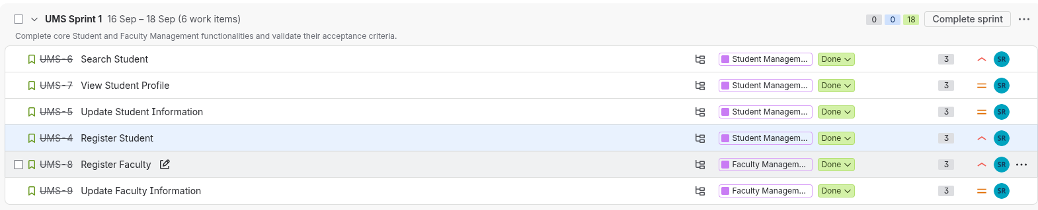

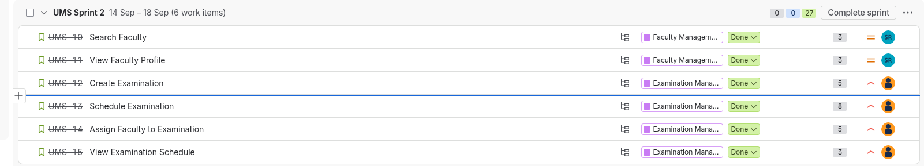

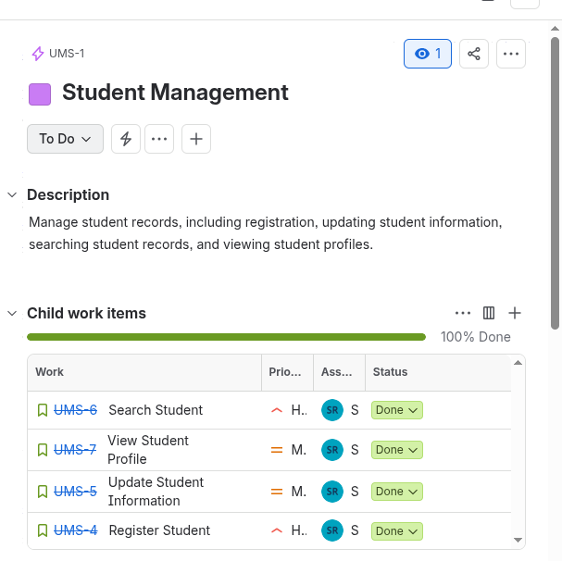
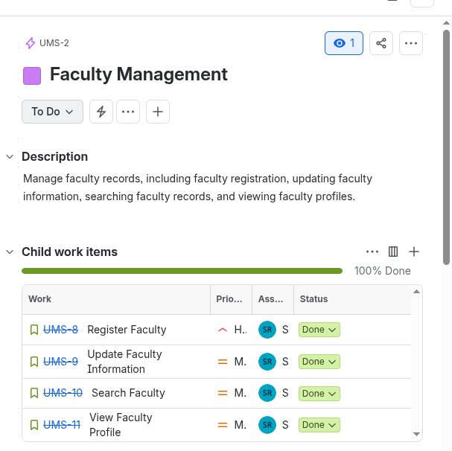
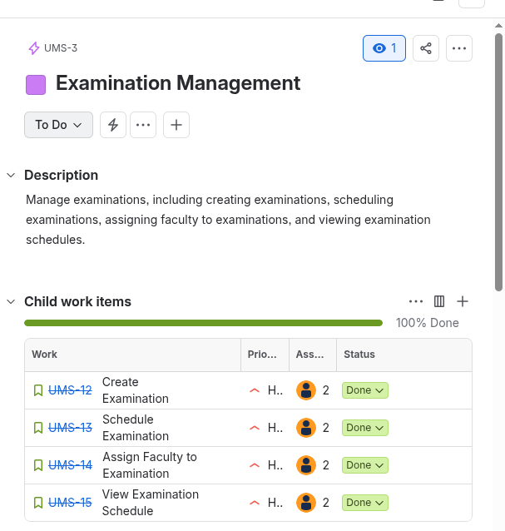

Question 7 — Extreme Programming (XP) Practices

(a) Pair Programming
Driver / Navigator: Person 2 (Driver) and Person 1 (Navigator), then roles swapped.
Task: Implementing the faculty double-booking conflict check for UMS-14.
Approximate Duration: 45 minutes, with roles swapped after 20 minutes.
Outcome: The conflict-check function was implemented and passed its test on the first run after pairing; the Navigator caught an edge case (a faculty member assigned to two exams starting at the exact same time) that the Driver had not initially handled.

7(b) Test-Driven Development (TDD) Cycle
Test Written First: A test asserting that scheduling two examinations in the same room with overlapping times should raise a conflict error.
Initially Failing Test: Since the scheduling function did not yet contain any conflict-checking logic, the test failed as expected (red).
Implementation: The minimum code needed to detect a room/time overlap and raise the conflict error was added to the scheduling function.
Final Verification: The test was re-run and passed (green), and the existing tests for the rest of the scheduling feature were also re-run to confirm nothing else was broken.

7(c) Refactoring
Before: The Create Examination (UMS-12) and Schedule Examination (UMS-13) stories each contained their own separate, near-identical code for validating that an exam date falls within the semester's date range.
Refactoring Performed: The duplicated logic was extracted into a single shared function, isValidExamDate(date, semesterStart, semesterEnd), which both stories now call instead of repeating the check.
After: Both UMS-12 and UMS-13 use the same shared function, removing the duplication.
Verification: The existing unit tests for both UMS-12 and UMS-13 were re-run after the refactor; all tests still passed unchanged, confirming that the external behavior of both features was preserved.

7(d) Continuous Integration
A GitHub Actions workflow was configured to run automatically on every push and pull request to the Examination Management branch, executing the project's unit test suite. For example, the commit “Add exam scheduling conflict check” triggered an automated test run before the change was merged into the main branch.
How Frequent Integration Helps: Integrating small changes frequently means that if a change breaks something, it is caught within one small commit rather than after several days of parallel work, which is especially important for a two-person team working under a tight two-sprint deadline.

7(e) XP Evidence Summary
Practice | Evidence | Proof | Outcome
Pair Programming | Both members paired on the UMS-14 conflict-check logic and swapped roles. | Pairing log with Driver/Navigator, task, and duration. | An edge case was caught during pairing that would likely have been missed working alone.
TDD | A complete red-green cycle was demonstrated for the UMS-13 conflict-check function. | Failing test commit followed by the passing implementation commit. | The conflict-detection logic was verified correct before being merged.
Refactoring | Duplicate date-validation logic in UMS-12 and UMS-13 was extracted into a shared helper function. | Before/after code diff plus a passing test-suite screenshot. | Reduced duplication and a single point of maintenance for exam-date rules.
Continuous Integration | GitHub Actions was configured to run tests on every push. | Workflow file plus a screenshot of a passing build. | A scheduling-conflict bug was caught by CI before reaching the main branch.

Question 8 — Sprint Execution

8(a) Sprint 1
Sprint Goal: Deliver core Student and Faculty record-management functionality.
Capacity: Approximately 2–3 days.
Stories selected and executed in Jira included the initial Student and Faculty Management stories, broken into tasks and assigned between both team members.

8(b) Daily Scrum
A Daily Scrum was held throughout both sprints, with each member stating what was completed, what would be done next, and any blocker. Evidence of these check-ins (brief written notes or chat logs with timestamps) is maintained alongside the Jira board.

8(c) Sprint 1 Review and Retrospective
At the Sprint 1 Review, the team demonstrated the completed Student and Faculty Management features against the Jira board and discussed which stories were fully done.
Retrospective improvements identified for Sprint 2 included:
- Writing acceptance criteria before starting implementation — owned by both members.
- Running CI checks on every commit rather than only at the end of the day — owned by Person 2.
- Logging Daily Scrum notes immediately rather than at the end of the sprint — owned by Person 1.

8(d) Sprint 2
Sprint 1 results were reviewed, the retrospective improvements above were applied, the backlog was reassessed, and the Product Owner/Scrum Master responsibilities were rotated between the two members.
Sprint 2 Goal: Deliver the remaining Faculty Management stories and the entire Examination Management epic (UMS-12 through UMS-15), fully integrated with Student and Faculty Management. All four Examination Management stories were completed and marked Done by the end of Sprint 2.

8(e) Sprint 1 vs Sprint 2 Comparison
Sprint 2 completed a higher total of story points than Sprint 1, reflecting the more complex Examination Management stories (including the 8-point Schedule Examination story). No blockers were carried over from Sprint 2 into a further sprint for Examination Management, since all four of its stories reached Done. Some Student Management stories reappear under a third sprint (UMS Sprint 3) on the board, which the team identifies as carry-over/rework rather than incomplete original work, and this is confirmed and explained during the viva.
Overall, the process improved between Sprint 1 and Sprint 2: acceptance criteria were written earlier, and CI was run more consistently on each commit, which reduced last-minute integration problems.

8(f) Lesson Learned and Process Change
Lesson Learned: Writing acceptance criteria before starting implementation made it much easier to know when a story was actually finished, rather than discovering missing behavior late in the sprint.
Process Change for a Third Sprint: The team would add an explicit issue-link between dependent stories in Jira (for example, marking Schedule Examination as “blocked by” Create Examination) so that sequencing dependencies are visible on the board itself, rather than only understood informally by the team.

Conclusion
This report has documented the University Management System (UMS) project across the full Agile lifecycle: problem definition and product vision, Agile and Scrum theory as applied to the project, the Product Backlog and Definition of Done, non-functional requirements, INVEST-evaluated user stories for Student and Examination Management, the Jira project configuration used to run the work, the XP engineering practices applied to the Examination Management feature, and the execution and comparison of two sprints. Screenshots and additional Jira/GitHub evidence should be inserted at the marked placeholders before final submission, and every team member should be able to explain the complete project during the viva.

